WAYBILL MANAGER v1.0

USER MANUAL

REVISION 1.0

TABLE OF CONTENTS

Chapter 1

1.0 System Requirement

.

**Operating System:** Microsoft Windows Vista/Win7 /Win 8 /Win10 32bit/64bit

**CPU:** Intel Pentium IV GHz 3.0 to Core i7 Series or Higher

**RAM:** 1G or Higher

**Display:** 1366x768 resolution or Higher

**Web Browser:** Internet Explorer 7.0 and above version, Safari 5.02 and above version, Mozilla Firefox 47 or above. Browser javascript function should be enabled for program function to work properly.

* 1. Accessing the application

The application can be launched from the web browser on the hosted ip as below:

Waybill manager address: <http://192.168.200.242>

Once launched the application redirects to the login page which requires login from an authorized email and password registered in the application.

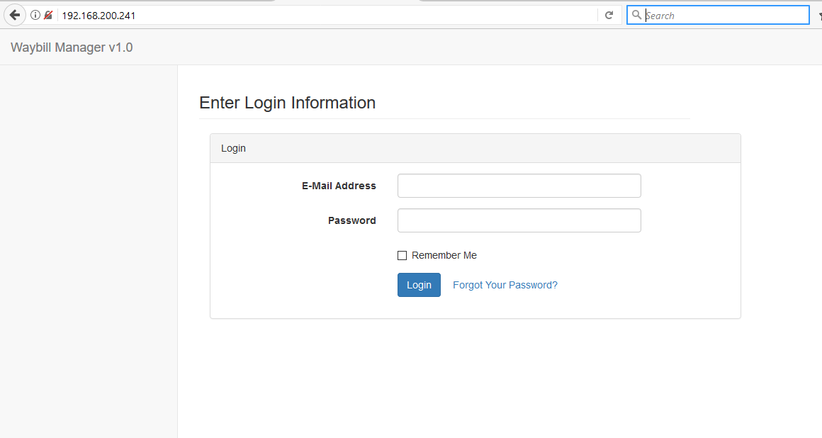

Chapter 2

2.0 Waybill Dashboard

On successful login into the application the user is directed to the waybill dashboard, the dashboard gives a summary of all waybill categories (Transferred, Loaned, Repairs and Promo).

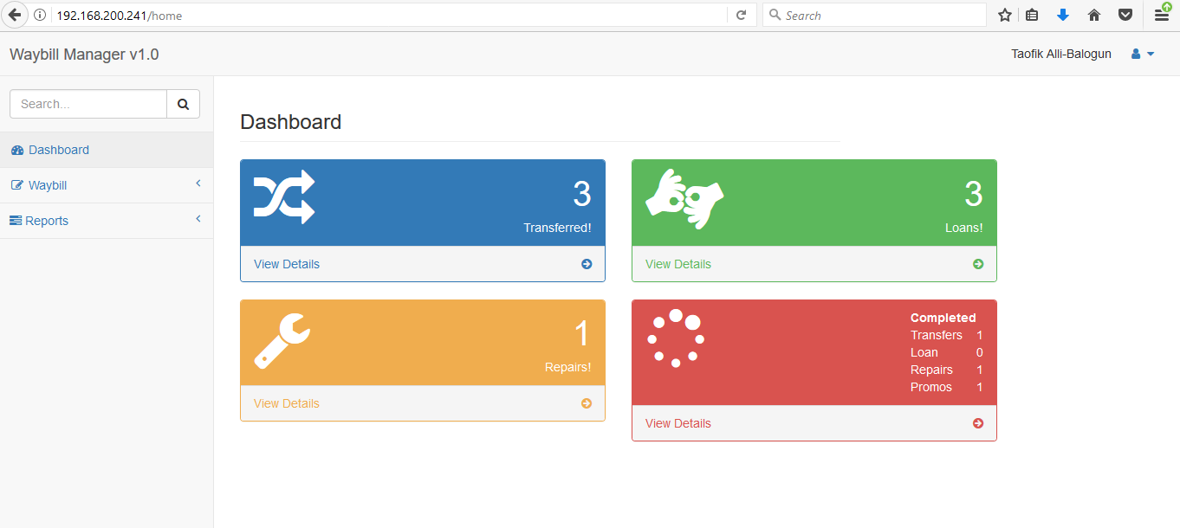

**2.1 Transferred:** This depicts waybill created for items being transferred between different company locations e.g. NPRNL IKOYI to NPRNL AGBARA. The transferred amount displayed shows all transfer (‘OPEN’ & ‘COMPLETED’) created by the logged in user. The transferred waybill can be closed/completed when the items have been received at the ‘Sent to” location.

**View details:** this links to the report page for all “OPEN” transferred waybills.

**2.2 Loans:** This shows waybill created for items being loaned out from the location to other company location or vendor. The loan item can only be closed when the item has been received back by the waybill creator.

**View details:** This links to the report page for all “OPEN” Loaned waybills.

**2.3 Repairs:**  Items in this waybill are expected to be returned within the expected return date, the items could be transferred to another company location or vendor for repair and can only be received /closed by the creator once items have been returned.

**View details:** This links to the report page for all “OPEN” repairs waybill.

**2.4 Promo:** items on this waybill are for one way items to be taken out of the company without return, could be transferred between locations or to vendor but does not require stringent confirmation to close/complete just an acknowledgement.

**2.5 Completed:**  this board lists count of all waybill type (transfer, loan, repairs & promo) that has been closed/completed/received.

**2.6 WAYBILL FLOW**

RETURNED

TRANSFER

LOAN/REPAIR

PRINT WAYBILL

CLOSED

PRINT WAYBILL

OPEN

FROM ITEM STOCK/LOCATION

TO ITEM STOCK/LOCATION

ITEM RECEIVED COMPLETELY

3.0 Creating New Waybill

Under the navigation bar by the left the drop down menu under waybill list the ‘create new waybill ‘, clicking on the link loads the ‘New Way bill‘ form.

The waybill information with asterisk * are important and shouldn’t be blank to avoid errors when submitting the form.

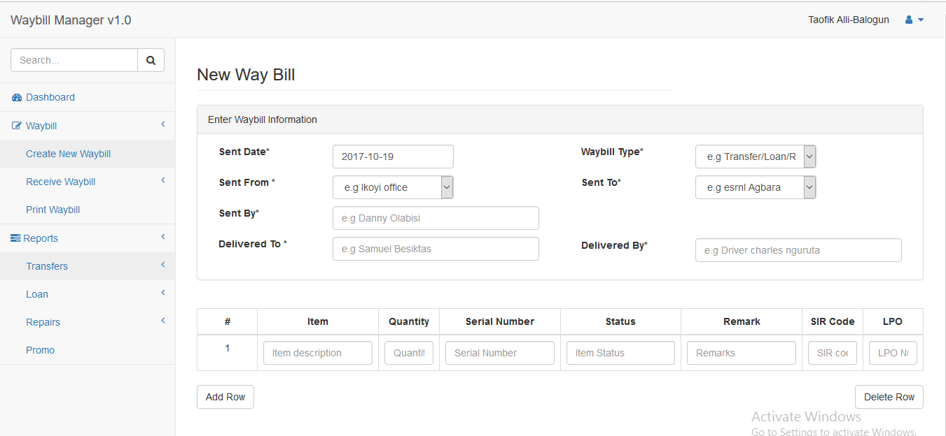

**Sent Date:** This field shows the current date which the waybill is created.

**Sent From:** This field shows the company and location of the current user or all other locations accessible to the user based on user privilege assigned.

**Sent By:** Name of waybill creator/user or person sending the items

**Delivered To:** The name of waybill/item recipient at the other company or location.

**Waybill type:** the type could be either Transfer/loan/Repair/Promo as explain in chapter 1.

**Sent To:** Specify the company and location where the waybill is being sent.

**Delivered By:** Specify courier for transporting waybill items to the recipient.